Interview proj for Ada

Content
1.home: introduction
- Hi! I’m Ada, and I really enjoy all forms of art/design! I started with ceramics in HS and it somehow led to me being in Parsons. In this class, I really hope to get comfortable with coding and with website design.
- 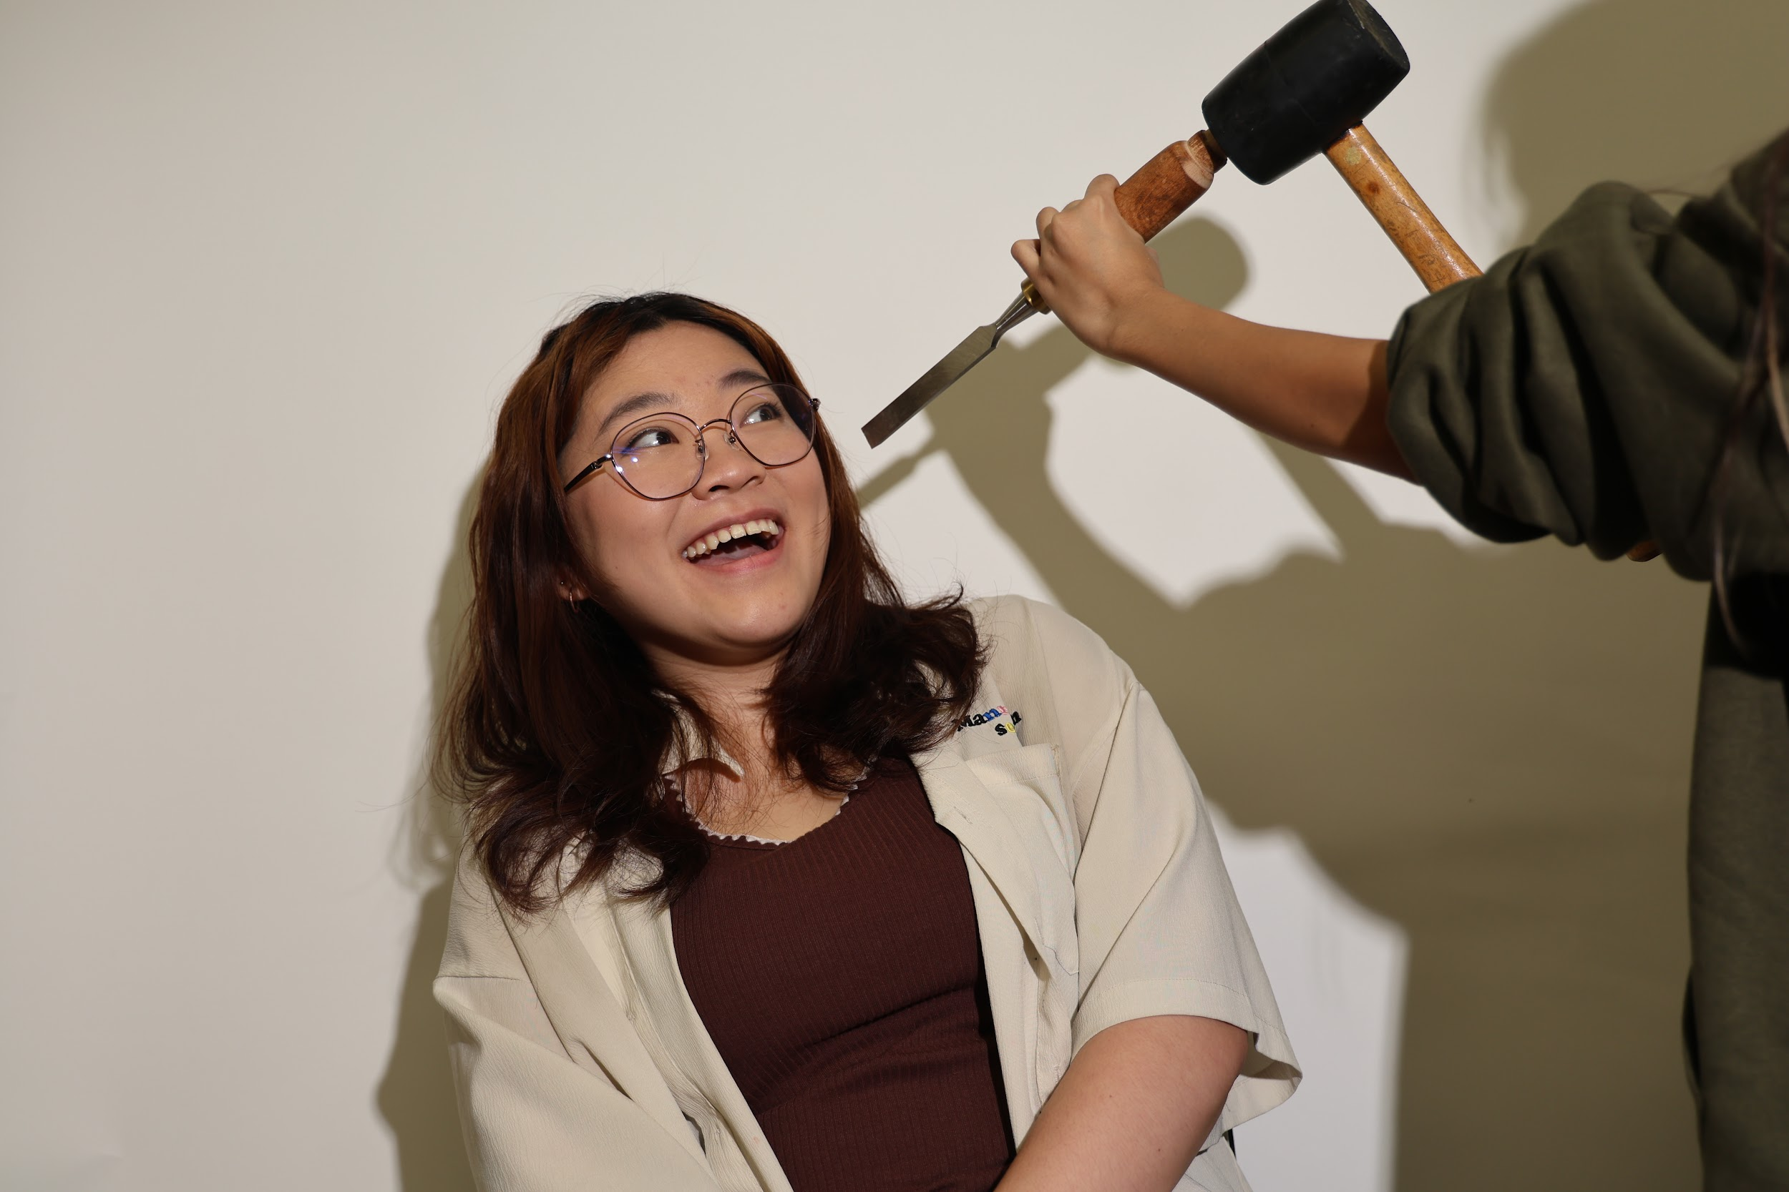
2.hometown
- Other than staying in NYC, I also live in San Jose. But before that, I was born in Canada, and have lived in Pittsburgh and Zhaozhuang throughout my childhood.
- 
3.introduce pet
- I have two cats! They are both girls and their names are Coffee and Snowy (you can probably guess which one is which).
- 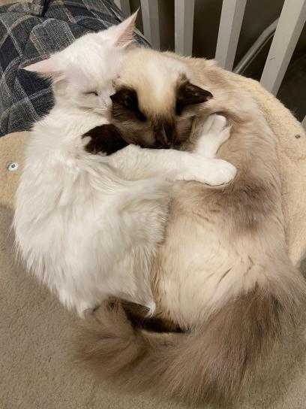
4.Hobbies: photography and ceramics
- I love doing digital photography as a hobby and I often take my camera around to shoot photos of what I see in my day-to-day life. I really want to get into film photography sometime in the future though. I also really enjoy ceramics, and I started working with it back in 10th grade of high school. I currently love making mini cats and throwing on the wheel.
- 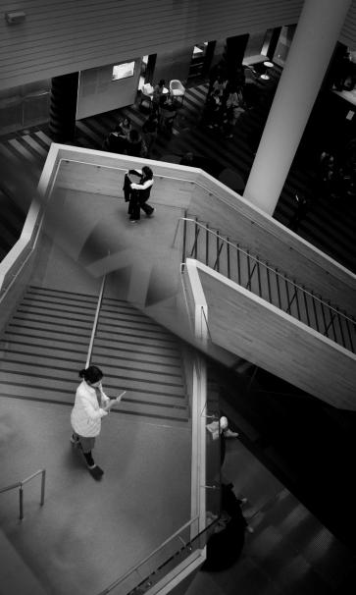
5.major, personal works
- I am a Product Design major and hopefully will complete the credits to become a Communication Design minor as well. I am currently in my sophomore year of school.
-6.diplaying one proj
- This project is a flatpack stool I made for Models, Mockups, and Prototypes last semester. It is made with maple, glue, and paracord. This project disassembles and is able to fit into a Medium size fedex box (inside dimensions: 13.25" x 11.5" x 2.38"). It is able to raise a person 11 inches off the ground and can support my professor's weight (who is well over 6 feet tall)!
- winter break
- Over winter break I spent a lot of time in my local ceramics studio, hung out with friends, ate a ton of good food, or just spent my time relaxing.
- Favourite food
- Currently, my favorite food is Liangpi. It’s this cold noodle dish from China that tastes both tangy and spicy. It is absolutely perfect for hot, summer days, although I can eat it during any time of the year.
- Favourite movie
- My favorite movie is Everything Everywhere All At Once. I think I have seen it roughly five times by now. In my opinion, it’s massive Oscar sweep was definitely deserved.
10.Favourite designer/artist
- Currently, I love Dieter Rams. He creates rather clean product designs that function very elegantly. He is most known for his work at Braun and his ten principles of “good design.” I love how all of his products are so thoroughly designed and how each and every part of it is intentional.

- 